**HANOI UNIVERSITY OF SCIENCE AND TECHNOLOGY**

**SCHOOL OF INFORMATION AND COMMUNICATION TECHNOLOGY**

**--- □** & **□ ---**

**FINAL PROJECT**

Module: Practicing computer architecture

Course code: IT3280

Instructor: Le Ba Vui

Group of students performing: 08

1. Tran Duc Manh - 20225739

2. Nguyen Nhuan Quang – 20225914

Code class : 147797

|  |  |  |
| --- | --- | --- |
| Surname and name | MSSV | Owner topic |
| Nguyen Nhuan Quang | 20225914 | 2. Drawing image above screen Bitmap image |
| Tran Duc Manh | 20225739 | 9. Drawing image equal sign ASCII text |

1. **Owner Topic : Drawing image above screen Bitmap image :**

**Topic :**

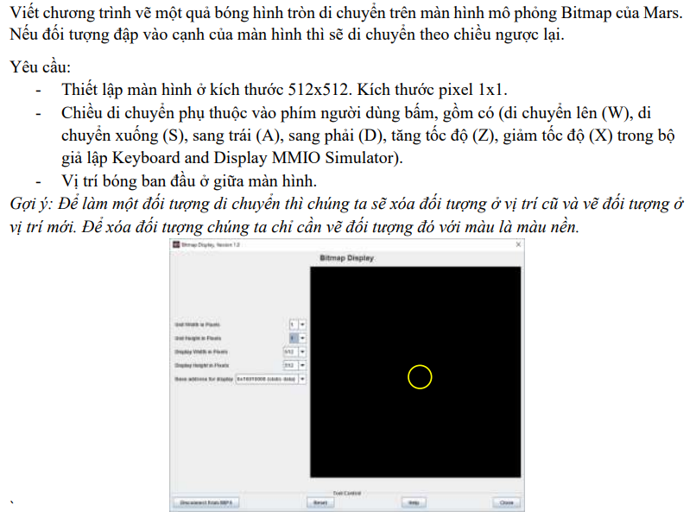

**Function explanation :**

* Main function: Initializes the first position for the center of the circle and calls the function to draw the circle
* Function main1: Enter the address of Keybroad and Display MMIO Simulator. Contains functions that perform input into Keybroad to control and check control commands
* Draw_circle function: Used to draw a circle by entering the address of the Bitmap Display in $s4 based on the parameters of the circle stored at $t8, $t9, $t0 which are the Ox axis position, Oy axis position respectively , circle color (Because $t4 contains the sleep time after each movement of the circle)
* Speed_up function: Used to speed up, access after entering 'z' on Keybroad

Speed up by reducing $t4 value by half

* Speed_down function: Used to reduce speed, accessed after entering 'x' on Keybroad

Speed up by doubling $t4 value

* Function turn_right: Used to handle input to go right

Increase the value of $t8 by 2 units each run

* Function turn_left: used to handle input to run left

Decreasing the value $t8 takes 2 units per run

* Turn_up function: Used to process input to run up

Decreasing the value $t9 takes 2 units per run

* Turn_down function: Used to handle input to run down

Increase the value of $t9 by 2 units each run

* Speed function: Performs sleep using $t4 ms

Determine running speed

**Algorithms and techniques:**

1. Polling and keyboard handling

* Poiling: The code uses polling to continuously check if a new key has been pressed by checking the `KEY_READY` register
* Handling key presses: When a key is pressed, the code reads the ASCII value from `KEY_CODE` and compares it with specific characters (z, x, d, a, w, s, p) to perform corresponding action
* **Branching** : History use the command thing event (` beq ` , ` bne ` ) to treat reason the the sue other each other based above code keys receive Okay .

1. Draw a circle

* Determine drawing position: Paragraph code count maths land only set miss based above sitting degree central heart belong to image round and click ruler screen image .
* Draw the road : Fig round Okay draw equal way body determined pixels needed​ draw based above sitting degree and access Japan land only set miss soy sauce response to show town color sharp of that pixel .

1. Movement control

* Updating coordinates: Functions ` turn_right ` , ` turn_left ` , ` turn_up ` , and ` turn_down ` access Japan sitting degree belong to image round ( the bar take note $t8 and $ t9 ) to move image round .
* Erase and draw again image round : Before when moving , fig​ round old Okay delete ( draw again with color black ), and after when moving , fig​ round new Okay drawing in position mind new ( draw again with color Yellow ).

1. Adjust speed

* Speed up : ` speed_up` function reduce time time wait ( increase speed degrees ) equals division in half time time wait .
* Reduce speed : Function ` speed_down ` increase time time wait ( decrease speed degrees ) equals way core pair time time wait .
* Time time wait : Time time wait between the moving times​ Okay thing control equal way history use one ring repeat and ` syscall ` to stop chapter submit in one about time time best determined .

1. Structure bamboo chapter submit and the function :

* Divide chapters submit wall the function : Paragraph code history use the command ` jal ` and ` jr ` to call and return about from the function , help structure bamboo chapter submit clearly clear than and easy tell maintain .

**Conclude fruit :**

**Video ends fruit :**



1. **Owner Topic : Drawing image equal sign ASCII character :**

**Topic post :**

**Making :**

* Initialize the string 'image' to save the original image you want to print, then update the address of Display MMIO.
* Inside the program allows a menu to be displayed for the user to enter options without having to run the program too much.
* In option1 (Display image on Display interface):

Use a loop to go through each index from beginning to end of the string and print it. When you encounter a NULL character, end the printing and return to the menu page.

* In option 2 (Display the image with only the frame on Display):   
  Browse from the beginning of the string and print the character for characters that are not color characters, and for color characters, before printing, convert it to white characters. (white space) ' ' then print it out.
* In option3 (Swap the positions of the characters and then display):

Browse each line of the image and save the specific position of the first character of the letter to be printed and start printing from that character until the end signal appears. Repeat it for each line

* In option4 (Allow users to enter colors and print new colors) :

Enter the color to change for each character '2' '1' and '3' and store it. Browse from the beginning of the string one by one and print out if it is different from the original color characters. If it is the original color character, check to see what character it is and replace it with the corresponding new color character.

* Option5 is to exit the program.
* The program allows users to select menus from 1 to 5. If the above numbers are different, the program prints a command asking the user to re-enter and the numbers must be from 1 to 5.

**Algorithm:***1. Menu Display and User Selection Algorithm:*

-Display menu: Use syscall with $v0 = 4 to print the menu string to the screen.

-Read selection: After displaying the menu, the program asks the user to enter an integer (menu selection) using syscall with $v0 = 5. The input value is saved in $t0 **.**

*2. User Selection Processing*

-Based on the value in $t0, the program will jump to the corresponding label (option1, option2, etc.) to process the selection. If the value is invalid (not between 1 and 5), the program prints an error message and returns to the main loop.

*3. Image Modification Algorithm*

modify_image: This algorithm iterates over each character of the image string, replacing the characters '2', '3', '1' with spaces. This creates an image with only the edges, removing internal details.

-Use the lb command to load each byte and sb to record the modified byte. The beq conditions check the current character and perform a replacement if there is a match.

*4. Algorithm to Import Colors and Apply to Images*

input_colors: This algorithm requires the user to enter color characters for 'D', 'C', 'E'. It then traverses the image string, replacing the characters '2', '1', '3' with the corresponding color characters.

-Use syscall to read characters from the user and store them in temporary variables. Then, iterate through the string and replace the corresponding characters.

*5. Image Display Algorithm*

display_image: This algorithm uses MMIO to display each character of the image string on the screen. It checks the display's readiness before writing characters to the DISPLAY_CODE address.

-Use a loop to iterate over each character of the string, check the display's ready status, and write the character to the display.

*6. Original Image Restoration Algorithm*

-After rendering, the program uses this algorithm to copy the original image from original_image back into image, ensuring that previous changes do not affect subsequent renderings.

-Go through each character of the original string and copy it into the image string.

**Simulation results for each option:**

Option 1: Display the original image

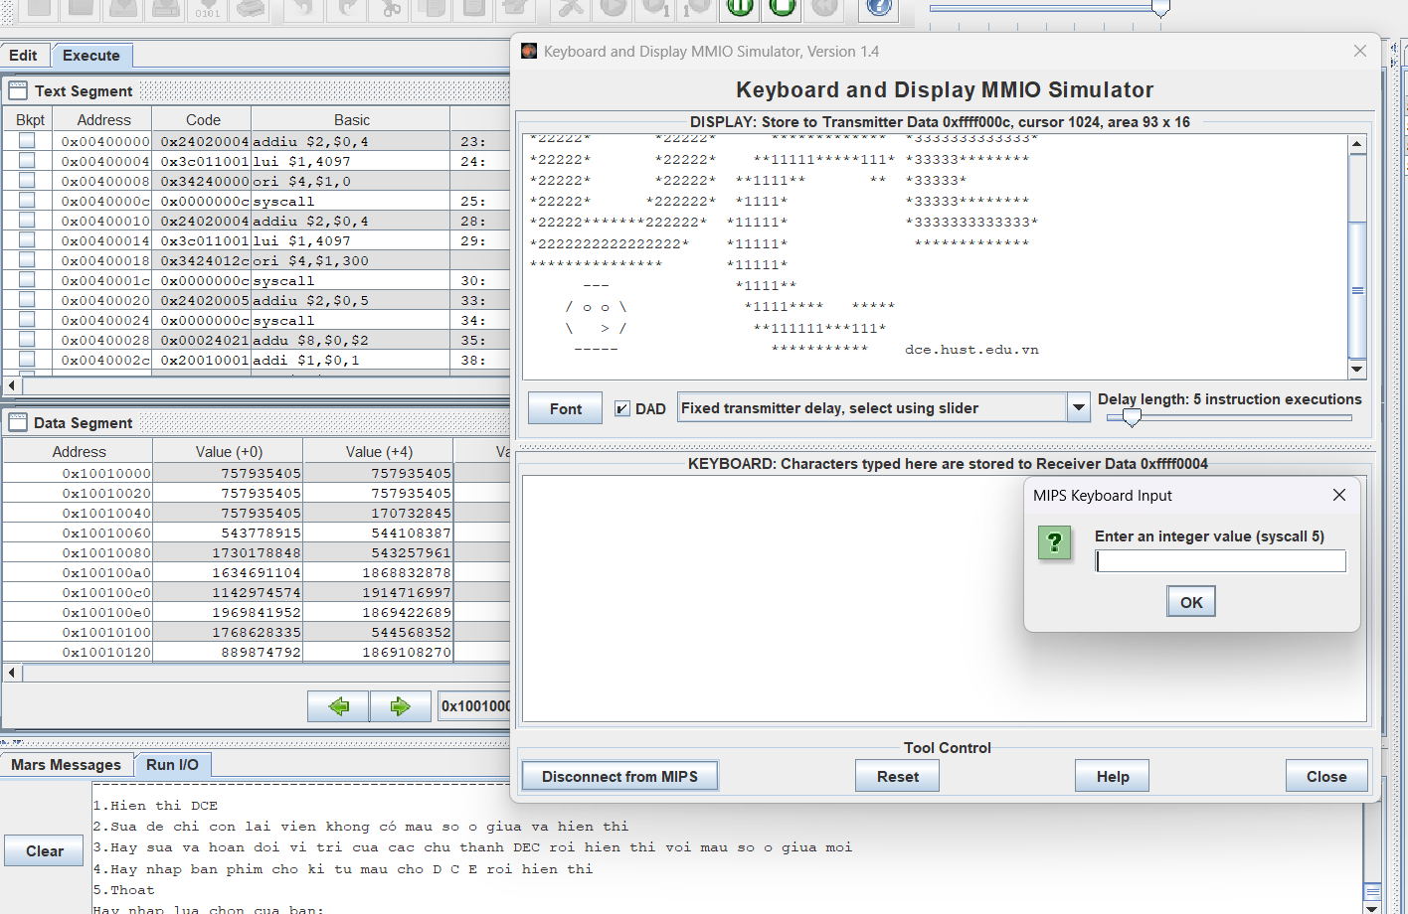

Option 2: Modify the image to show only the border and then display it

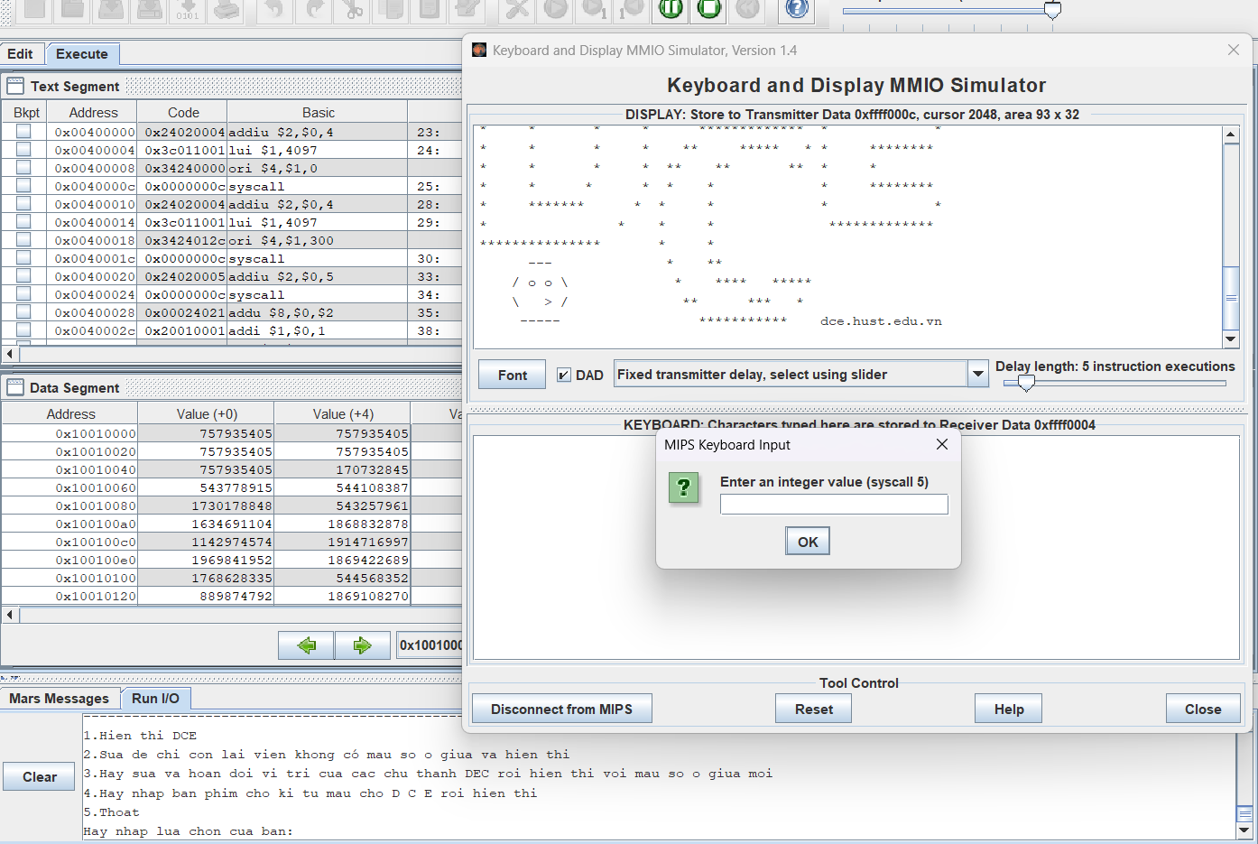

Option 3: Swap the position of the characters in the image and display.

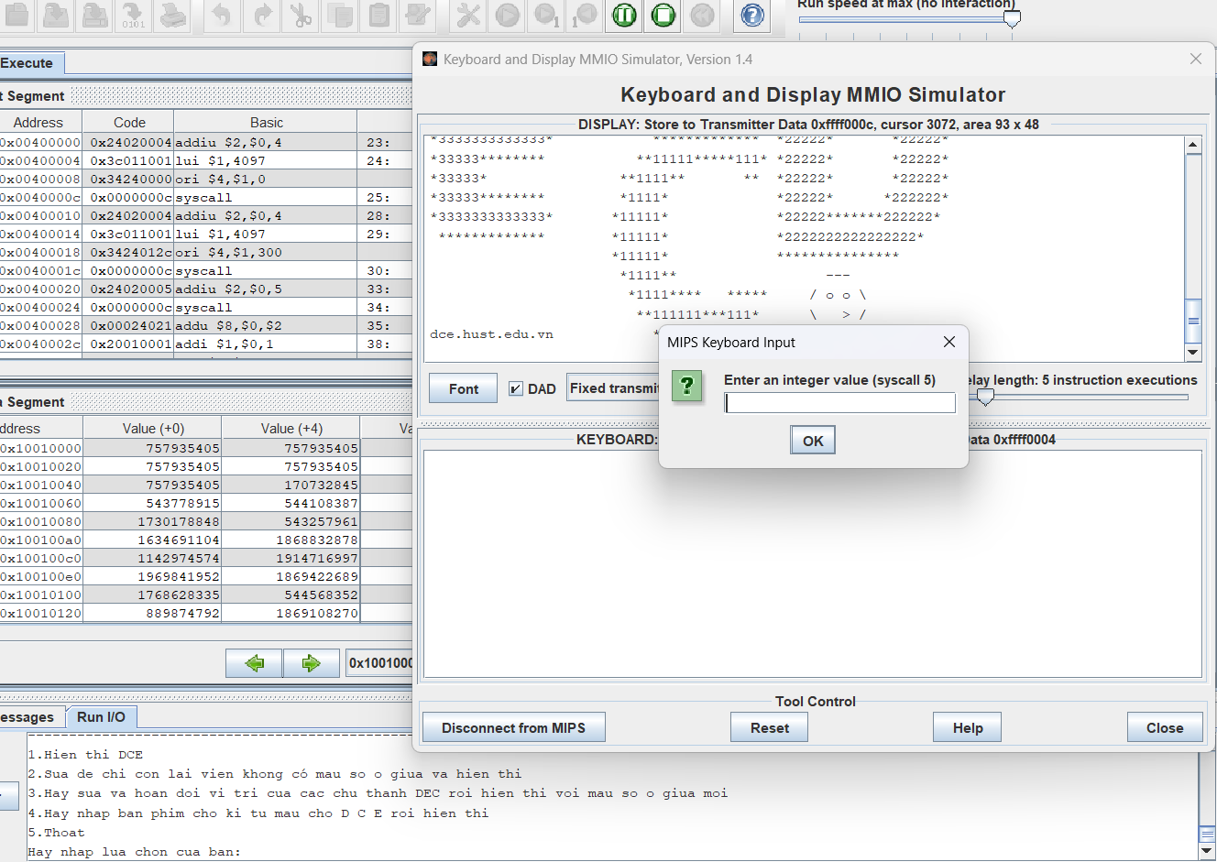

Option 4: Allows users to enter colors for the characters D, C, E and then displays the colored image.

